Digital Pirani Vacuum Gauge – DPRG-1GH-2SP
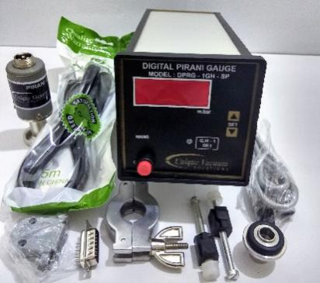
The UVS Model DPRG series Vacuum Pirani Gauge Controller displays vacuum pressure as measured from a S-PR-GH sensor tube. It displays vacuum measurements based on thermal conductivity of gases. The Model DPRG-1GH-2SP unit covers the range from 0.001 m.Bar to 20 m.bar, and controls relay with independent dual set points. With this option, user can set two individual relay set points for HI & LO values.
TECHNICAL SPECIFICATIONS
Number of sensor channels | ONE
Display Range | 1000 mBar to 0.001mBar.
Measuring Range | 20 mBar to 0.001mBar.
Units of Display | m.Bar
Vacuum Gauge Head | S-PR-GH sensor tube
Temp. Range | +2 to +50 deg. Celsius
VAC. Display | 4-digit bright red LED, 14 mm high
VAC and ATM Adjust | adjusted by trim pot at the signal conditioner PCB.
Process control set points | one
Process Control Relays | Two relay outputs, potential free contacts; independent available through the DB15 accessory connector on the rear panel
Nonvolatile Memory | Only for set points
Operating Voltage | universal power supply, input voltages from 90 ~ 264VAC 50/60 Hz
Mounting | ¼ DIN 92 x 92 mm (3.62” x 3.62")
Environmental Considerations | not for use with explosive or corrosive gases
Overall dimensions | 92mm X 92mm X 110mm Depth
Optional outputs on request | RS485, 0 -10V Dc analog output
Features at a Glance : ■ Measurement range 0.001 to 20 mbar ■ Space saving rugged design- 1/8 DIN console ■ Space saving rugged design- 1/8 DIN console ■ Mounts in any orientation ■ brass body measuring cell with metal-sealed feed through ■ with universal power supply – input voltage from 90 ~ 264VAC, frequency 47 ~ 440Hz
Calibration:
Unique Vacuum Solutions offers a convenient recalibration service to help users of vacuum measurement pirani/ thermocouple/ full range gauges to maintain all of their vacuum gauges in Certified and peak condition, regardless of the original manufacturer. All makes of vacuum gauges can also be calibrated / repaired if required.
The calibration certificates are available only on request at additional cost. Pl contact before ordering.

UNIQUE VACUUM SOLUTIONS
#57, 8th cross, 1st B cross, Daddanna industrial area main road, vishwaneedam post, Near Peenya 2nd stage, Bangalore -560091
Ph: 080-28367059, 9886726920. e mail: support@uniquevacuum.co.in, www.uniquevacuum.co.in

